1. **Perform basic Image Handling and processing operations on the image. • Read an image in python and Convert an Image to Grayscale**

**AIM:** To Perform Basic Operations to Read Image and Convert to Grayscale using Python .

**Program :**

* + import cv2
  + import numpy as np
  + kernel = np.ones((5,5),np.uint8)
  + print(kernel)
  + path ="C:\drive\OneDrive\Pictures\pass photo.jpg"
  + img =cv2.imread(path)
  + imgGray = cv2.cvtColor(img,cv2.COLOR_BGR2GRAY)
  + cv2.imshow("GrayScale",imgGray)
  + cv2.waitKey(0)

INPUT :

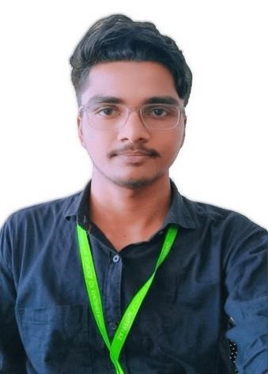

OUTPUT:

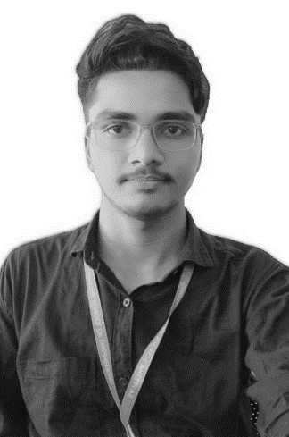

1. **Perform basic Image Handling and processing operations on the image.• Read an image in python and Convert an Image to Blur using GaussianBlur.**

**AIM:** To Perform Basic Operations to Read Image and Convert to Blur using GaussianBlur.

**PROGRAM :**

* + import cv2
  + import numpy as np
  + kernel = np.ones((5,5),np.uint8)
  + print(kernel)
  + path = "C:/Users/vempa/Downloads/lab 2.jpg"
  + img =cv2.imread(path)
  + imgGray = cv2.cvtColor(img,cv2.COLOR_BGR2GRAY)
  + imgBlur = cv2.GaussianBlur(imgGray,(7,7),0)
  + cv2.imshow("Img Blur",imgBlur)
  + cv2.waitKey(0)

INPUT :

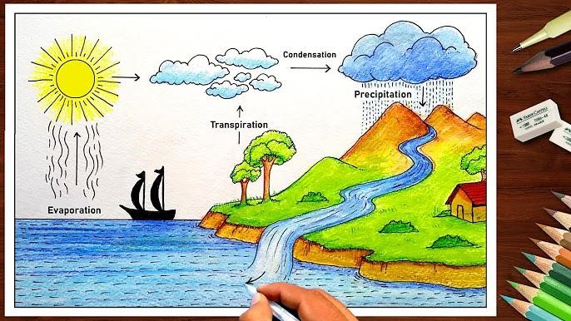

OUTPUT :

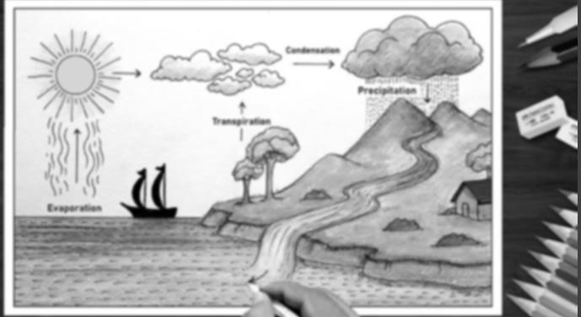

1. **Perform basic Image Handling and processing operations on the image• Read an image in python and Convert an Image to show outline using Canny function**

**AIM:** To Perform Basic Operations to Convert image to show outline Canny function in Python.

**PROGRAM:**

* + import cv2
  + import numpy as np
  + kernel = np.ones((5,5),np.uint8)
  + print(kernel)
  + path = "C:/Users/vempa/Downloads/lab 2.jpg"
  + img =cv2.imread(path)
  + imgGray = cv2.cvtColor(img,cv2.COLOR_BGR2GRAY)
  + imgBlur = cv2.GaussianBlur(imgGray,(7,7),0)
  + imgCanny = cv2.Canny(imgBlur,100,200)
  + cv2.imshow("Img Canny",imgCanny)
  + cv2.waitKey(0)

INPUT :



OUTPUT :

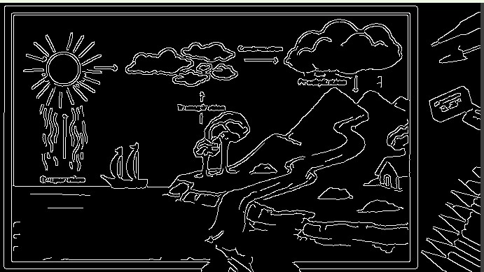

1. **Perform basic Image Handling and processing operations on the image• Read an image in python and Dilate an Image using Dilate function**

**AIM:** To Perform Basic Operations to Read Image and Dilate an Image using Python

**PROGRAM:**

* + import cv2
  + import numpy as np
  + kernel = np.ones((5,5),np.uint8)
  + print(kernel)
  + path = "C:/Users/vempa/Downloads/LAB4.jpg"
  + img =cv2.imread(path)
  + imgGray = cv2.cvtColor(img,cv2.COLOR_BGR2GRAY)
  + imgBlur = cv2.GaussianBlur(imgGray,(7,7),0)
  + imgCanny = cv2.Canny(imgBlur,100,200)
  + imgDilation = cv2.dilate(imgCanny,kernel , iterations = 10)
  + imgEroded = cv2.erode(imgDilation,kernel,iterations=2)
  + cv2.imshow("Img Erosion",imgEroded)
  + cv2.waitKey(0)

**INPUT :**

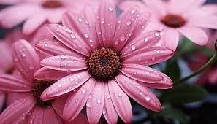

**OUTPUT:**

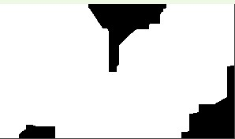

1. **Perform basic Image Handling and processing operations on the image• Read an image in python and Erode an Image using erode function**

**AIM:** The Aim of the experiment is to Read an image in python and Erode an Image using erode function

**PROGRAM:**

* + import cv2
  + import numpy as np
  + kernel = np.ones((5,5),np.uint8)
  + print(kernel)
  + path ="C:/Users/vempa/Downloads/HD-wallpaper-tom-and-jerry-cartoons.jpg"
  + img =cv2.imread(path)
  + imgGray = cv2.cvtColor(img,cv2.COLOR_BGR2GRAY)
  + imgBlur = cv2.GaussianBlur(imgGray,(7,7),0)
  + imgCanny = cv2.Canny(imgBlur,100,200)
  + imgDilation = cv2.dilate(imgCanny,kernel , iterations = 10)
  + imgEroded = cv2.erode(imgDilation,kernel,iterations=2)
  + cv2.imshow("Img Erosion",imgEroded)

**INPUT :**

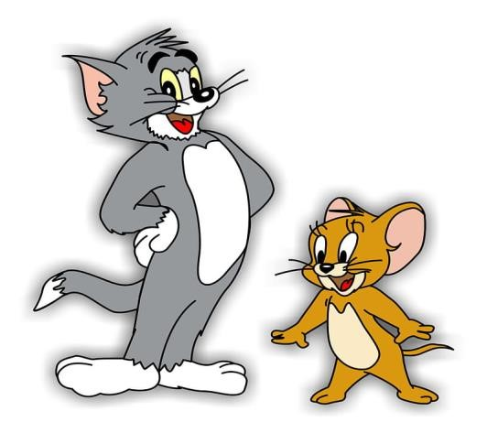

**OUTPUT:**

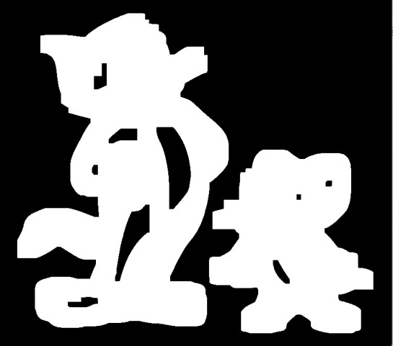

1. **Perform basic video processing operations on the captured video• Read captured video in python and display the video, in slow motion and in fast motion.**

**AIM:** The Aim of the Experiment is to Read captured video in python and display the video, in slow motion and in fast motion

**PROGRAM:**

import cv2 def play_video(video_path, speed=1.0): cap = cv2.VideoCapture(video_path) if not cap.isOpened():

print("Error opening video file") return

fps = cap.get(cv2.CAP_PROP_FPS) new_fps = fps * speed while cap.isOpened(): ret, frame = cap.read() if not ret: break

cv2.imshow('Video Player', frame)

if cv2.waitKey(int(1000 / new_fps)) & 0xFF == 27: # Press 'Esc' to exit

break cap.release() cv2.destroyAllWindows()

video_path = "C:/drive/OneDrive/Pictures/Slide Shows/Ram's/WA-VID-20200720-9aa8edb7.mp4" play_video(video_path, speed=0.5) play_video(video_path, speed=2.0)

**INPUT : OUTPUT :**

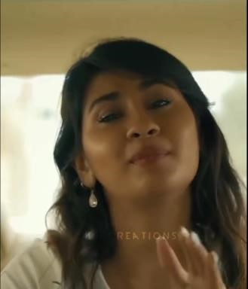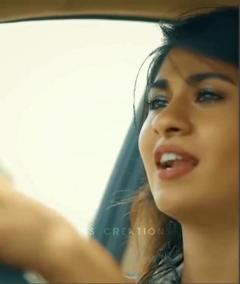

**7. Capture video from web Camera and Display the video, in slow motion and in fast motion operations on the captured video**

**AIM:**The Aim is to Capture video from web Camera and Display the video, in slow motion and in fastmotion operations on the captured video **PROGRAM:**

import cv2 def display_video_slow_fast(video_path, slow_factor=0.5, fast_factor=2.0):

cap = cv2.VideoCapture(video_path) if not cap.isOpened():

print("Error: Could not open video device or file.") return while True:

ret, frame = cap.read() if not ret:

print("Error: Failed to capture frame.") break cv2.imshow('Original Video', frame) slow_frame = cv2.resize(frame, None, fx=slow_factor,fy=slow_factor,interpolation=cv2.INTER_LINEAR) cv2.imshow('Slow Motion', slow_frame)

fast_frame = cv2.resize(frame, None, fx=fast_factor, fy=fast_factor, interpolation=cv2.INTER_LINEAR) cv2.imshow('Fast Motion', fast_frame) if cv2.waitKey(1) & 0xFF == ord('q'):

break cap.release()

cv2.destroyAllWindows() video_path = 0 display_video_slow_fast(video_path) **OUTPUT :**

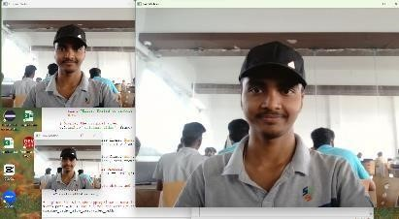

1. **Scaling an image to its Bigger and Smaller sizes. AIM:** The Aim is resize the image from bigger to smaller size **PROGRAM :**

import cv2 import numpy as np kernel

= np.ones((5,5),np.uint8)

img = cv2.imread("C:/Users/vempa/Downloads/BIRD.jpg",cv2.IMREAD_COLOR) img = cv2.resize(img,(600,600)) cv2.imshow("image",img) cv2.waitKey(0) **INPUT :**

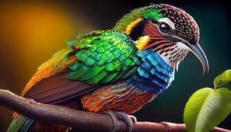

**OUTPUT:**

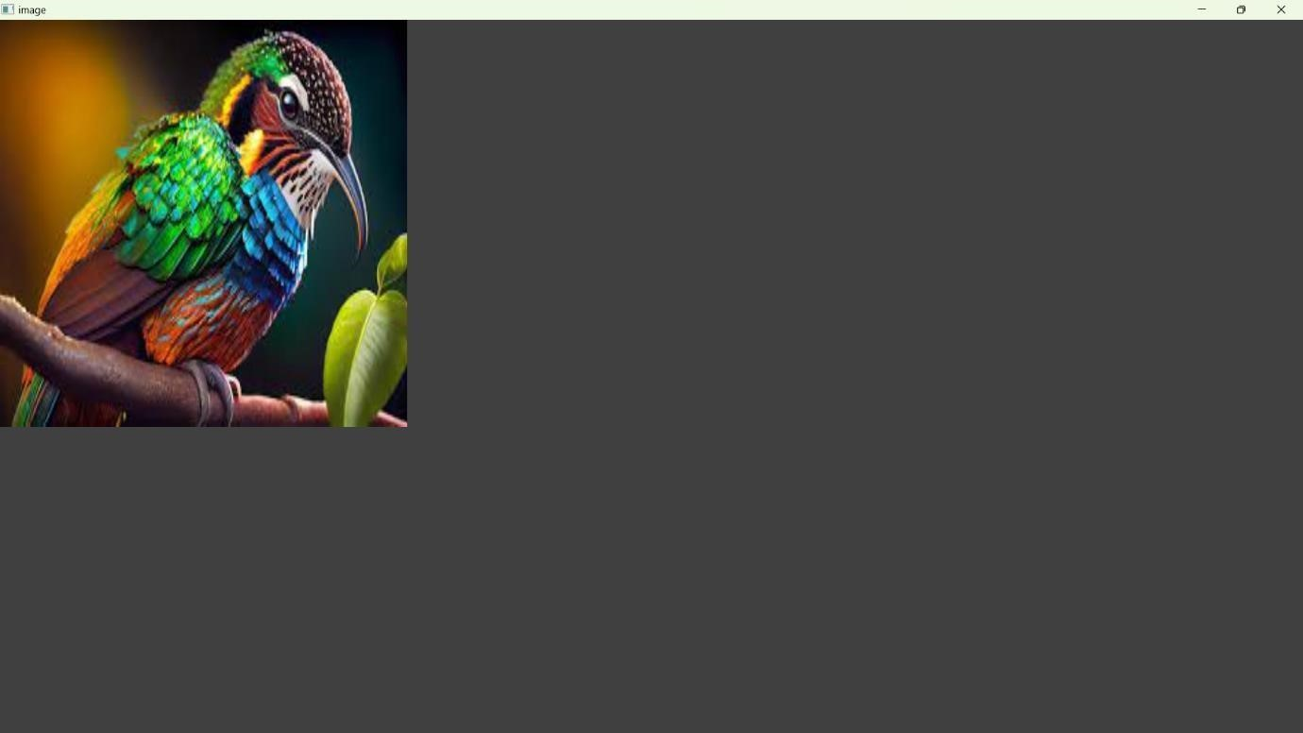

1. **Perform Rotation of an image to clockwise and counter clockwise direction.**

**ROTATION 90 ALONG DEGREE:**

**AIM :**The Aim of the Experiment is to perform Rotation of an image along 90 degree **PROGRAM:**  import cv2

path = r"C:\Users\vempa\Downloads\BIRD2.jpg" src = cv2.imread(path) window_name = 'Image'

image = cv2.rotate(src, cv2.ROTATE_90_COUNTERCLOCKWISE) cv2.imshow(window_name, image) cv2.waitKey(0) **INPUT:**



**OUTPUT:**

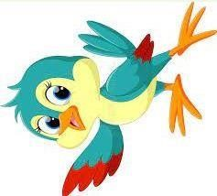

**10.ROTATION ALONG 180 DEGREE**

**AIM** :The Aim of the Experiment is to perform Rotation of an image along 180 degree.

**PROGRAM :**

import cv2

path=r"C:\Users\vempa\Downloads\BIRD2.jpg" src = cv2.imread(path) window_name = 'Image' image =

cv2.rotate(src, cv2.ROTATE_180)

cv2.imshow(window_name, image) cv2.waitKey(0) **INPUT:**



**OUTPUT:**

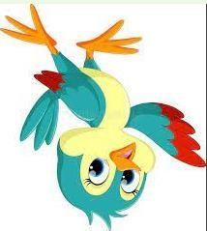

**11. Perform Affine Transformation on the image**.

**AIM :** To Perform Affine Transformation on the image.

**PROGRAM :**

import cv2 import numpy as np

img = cv2.imread(r"C:\Users\vempa\Downloads\BIRD2.jpg")

rows,cols,_ = img.shape pts1 = np.float32([[50,50],[200,50],[50,200]]) pts2 = np.float32([[10,100],[200,50],[100,250]]) M = cv2.getAffineTransform(pts1,pts2) dst =

cv2.warpAffine(img,M,(cols,rows)) cv2.imshow("Affine Transform", dst) cv2.waitKey(0) cv2.destroyAllWindows() **INPUT:**



**OUTPUT:**

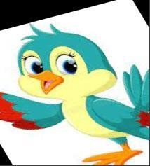

**12. Perform Perspective Transformation on the image. AIM :** To Perform Perspective Transformation on the image **PROGRAM :**

import cv2 import numpy as np

img = cv2.imread(r"C:\Users\vempa\Downloads\BIRD2.jpg") rows,cols,ch = img.shape

pts1 = np.float32([[56,65],[368,52],[28,387],[389,390]]) pts2 = np.float32([[100,50],[300,0],[0,300],[300,300]]) M = cv2.getPerspectiveTransform(pts1,pts2) dst = cv2.warpPerspective(img,M,(cols, rows)) cv2.imshow('Transformed Image', dst) cv2.waitKey(0) cv2.destroyAllWindows() **INPUT:**



**OUTPUT :**

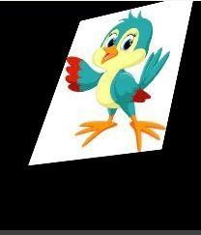

**13. Perform Perspective Transformation on the Video**

**PROGRAM:**

import cv2 import numpy as np cap = cv2.VideoCapture(r"C:\Users\vempa\Videos\test.mp4") while True:

ret, frame = cap.read() pts1 = np.float32([[200,300], [5, 2],[0, 4], [6, 0]]) pts2 = np.float32([[0, 0], [4, 0],[0, 1], [4, 6]]) matrix = cv2.getPerspectiveTransform(pts1, pts2) result = cv2.warpPerspective(frame, matrix, (0, 0)) cv2.imshow('frame', frame) # Initial Capture cv2.imshow('frame1', result) # Transformed Capture if cv2.waitKey(24) == 27:

break

cap.release() cv2.destroyAllWindows**() OUTPUT:**

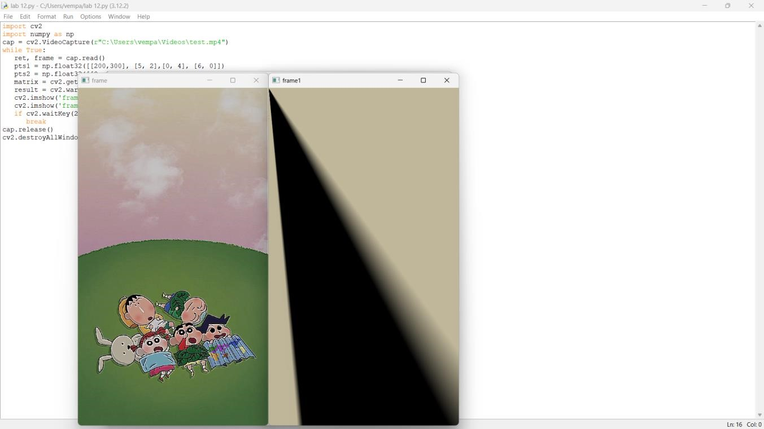

**14. Perform transformation using Homography matrix**

**PROGRAM:**

import cv2 import numpy as np im_src = cv2.imread(r"C:\Users\vempa\Downloads\BIRD2.jpg")

pts_src = np.array([[141, 131], [480, 159], [493, 630],[64, 601]]) im_dst = cv2.imread(r"C:\Users\vempa\Downloads\BIRD2.jpg")

pts_dst = np.array([[318, 256],[534, 372],[316, 670],[73, 473]]) h, status = cv2.findHomography(pts_src, pts_dst) im_out = cv2.warpPerspective(im_src, h, (im_dst.shape[1],im_dst.shape[0])) cv2.imshow("Source Image", im_src) cv2.imshow("Destination Image", im_dst) cv2.imshow("Warped Source Image", im_out) cv2.waitKey(0) **OUTPUT:**

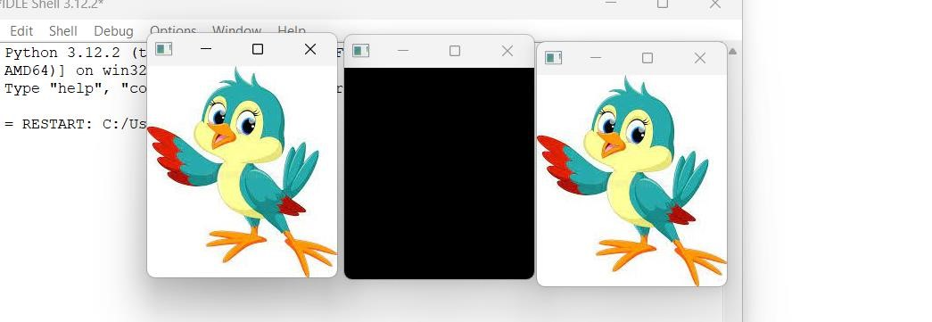

1. **Perform transformation using Direct Linear Transformation**

**PROGRAM**

import cv2 import numpy as np img1 = cv2.imread(r"C:/Users/vempa/Downloads/HD-wallpaper-tom-and-jerry-cartoons.jpg") img2 = cv2.imread(r"C:\Users\vempa\Downloads\LAB4.jpg") pts1 = np.array([[50, 50], [200, 50], [50, 200], [200, 200]]) pts2 = np.array([[100, 100], [300, 100], [100, 300], [300, 300]]) H, _ = cv2.findHomography(pts1, pts2) dst = cv2.warpPerspective(img1, H, (img2.shape[1], img2.shape[0])) cv2.imshow('img1', img1) cv2.imshow('img2', img2) cv2.imshow('dst', dst) cv2.waitKey(0) cv2.destroyAllWindows() **OUTPUT:**

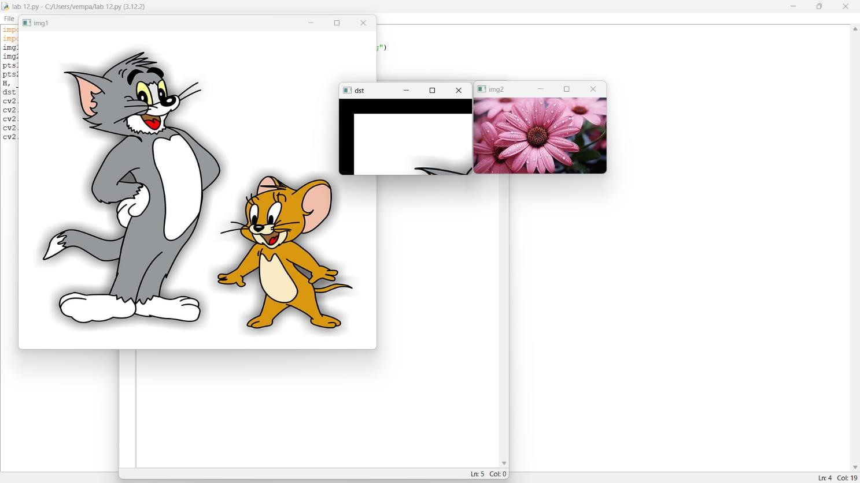

1. **Perform Edge detection using canny method**

**PROGRAM:**

import cv2

# Read the input image image_path = r"C:\Users\vempa\Downloads\BIRD2.jpg" original_image = cv2.imread(image_path, cv2.IMREAD_GRAYSCALE)

# Check if the image is successfully loaded if original_image is None:

print("Error: Could not load the image.") else:

# Apply Gaussian blur to reduce noise and improve edge detection blurred_image = cv2.GaussianBlur(original_image, (5, 5), 0)

# Apply Canny edge detection edges = cv2.Canny(blurred_image, 50, 150) # Adjust the threshold values as needed

# Display the original image and the result cv2.imshow("Original Image", original_image) cv2.imshow("Canny Edge Detection", edges) cv2.waitKey(0) cv2.destroyAllWindows() **OUTPUT:**

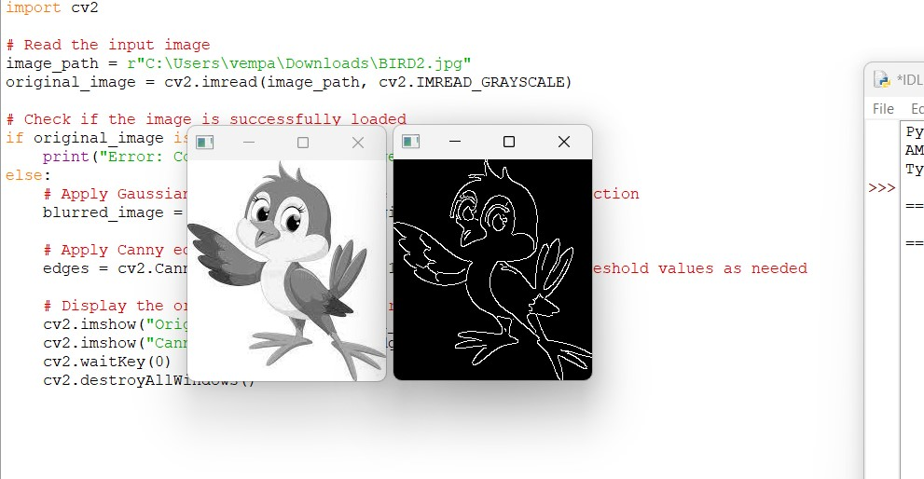

**17. Perform Edge detection using Sobel Matrix along X axis**

**PROGRAM:**

import cv2 img = cv2.imread(r"C:\Users\vempa\Downloads\BIRD2.jpg") cv2.imshow('Original', img) cv2.waitKey(0) img_gray = cv2.cvtColor(img, cv2.COLOR_BGR2GRAY)

# Blur the image for better edge detection img_blur = cv2.GaussianBlur(img_gray, (3,3), 0)

sobelx = cv2.Sobel(src=img_blur, ddepth=cv2.CV_64F, dx=1, dy=0, ksize=5) # Sobel Edge Detection on the X axis

cv2.imshow('Sobel X', sobelx) cv2.waitKey(0) **OUTPUT:**

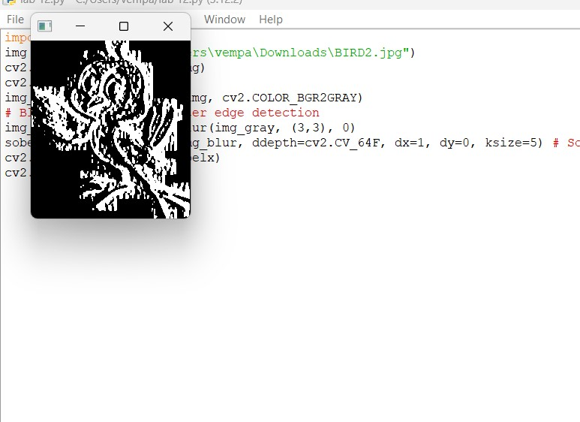

**18. Perform Edge detection using Sobel Matrix along Y axis**

**PROGRAM:**

import cv2

# Read the original image img = cv2.imread(r"C:\Users\vempa\Downloads\BIRD2.jpg")

# Display original image cv2.imshow('Original', img) cv2.waitKey(0) # Convert to graycsale img_gray = cv2.cvtColor(img, cv2.COLOR_BGR2GRAY)

# Blur the image for better edge detection img_blur = cv2.GaussianBlur(img_gray, (3,3), 0)

# Sobel Edge Detection

sobely = cv2.Sobel(src=img_blur, ddepth=cv2.CV_64F, dx=0, dy=1, ksize=5) # Sobel Edge Detection on the Y axis

# Display Sobel Edge Detection Images cv2.imshow('Sobel Y', sobely) cv2.waitKey(0) **OUTPUT:**

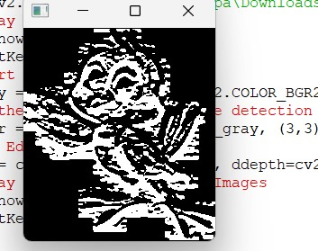

**19. Perform Edge detection using Sobel Matrix along XY axis**

**PROGRAM :**

import cv2 img = cv2.imread(r"C:\Users\vempa\Downloads\BIRD2.jpg")

# Display original image cv2.imshow('Original', img) cv2.waitKey(0) img_gray = cv2.cvtColor(img, cv2.COLOR_BGR2GRAY)

# Blur the image for better edge detection img_blur = cv2.GaussianBlur(img_gray, (3,3), 0)

sobelxy = cv2.Sobel(src=img_blur, ddepth=cv2.CV_64F, dx=1, dy=1, ksize=5) # Combined X and Y Sobel Edge Detection cv2.imshow('Sobel X Y using Sobel() function', sobelxy) cv2.waitKey(0) OUTPUT:

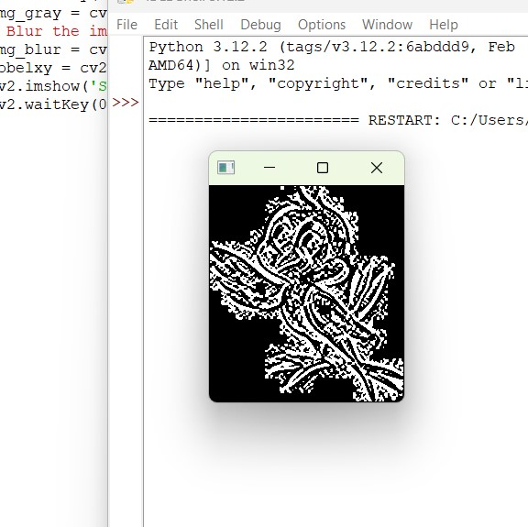

1. **Perform Sharpening of Image using Laplacian mask with negative center coefficient.**

**PROGRAM:**

import cv2 import numpy as np img = cv2.imread(r"C:\Users\vempa\Downloads\HD-wallpaper-tom-and-jerry-cartoons.jpg") gray = cv2.cvtColor(img, cv2.COLOR_BGR2GRAY)

kernel = np.array([[0,1,0], [1,-8,1], [0,1,0]]) sharpened = cv2.filter2D(gray, -1, kernel) cv2.imshow('Original', gray) cv2.imshow('Sharpened', sharpened) cv2.waitKey(0) cv2.destroyAllWindows() **OUTPUT:**

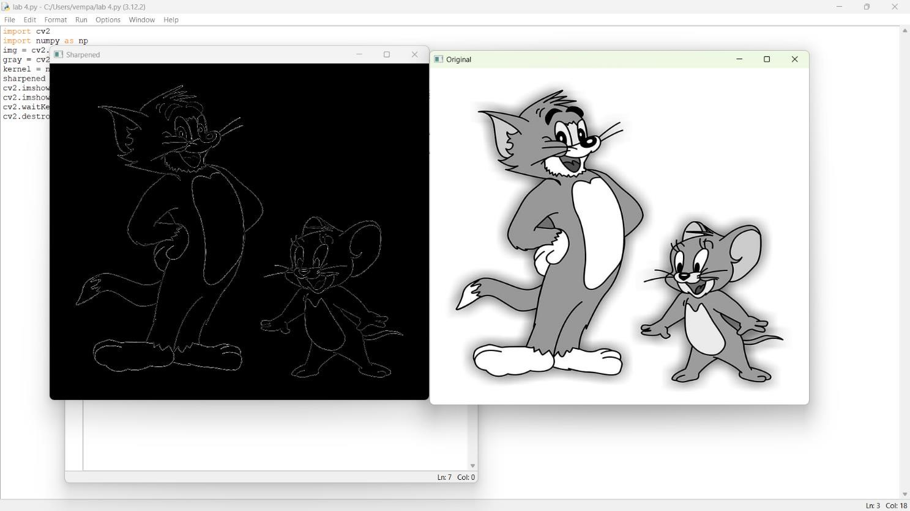

1. **Perform Sharpening of Image using Laplacian mask implemented with an extension of diagonal neighbors,**

**PROGRAM :**

import cv2 import numpy as np img = cv2.imread(r"C:\Users\vempa\Downloads\BIRD2.jpg") gray = cv2.cvtColor(img, cv2.COLOR_BGR2GRAY)

kernel = np.array([[0,1,0], [1,-4,1], [0,1,0]]) sharpened = cv2.filter2D(gray, -1, kernel) cv2.imshow('Original', gray) cv2.imshow('Sharpened', sharpened) cv2.waitKey(0) cv2.destroyAllWindows() **OUTPUT**:

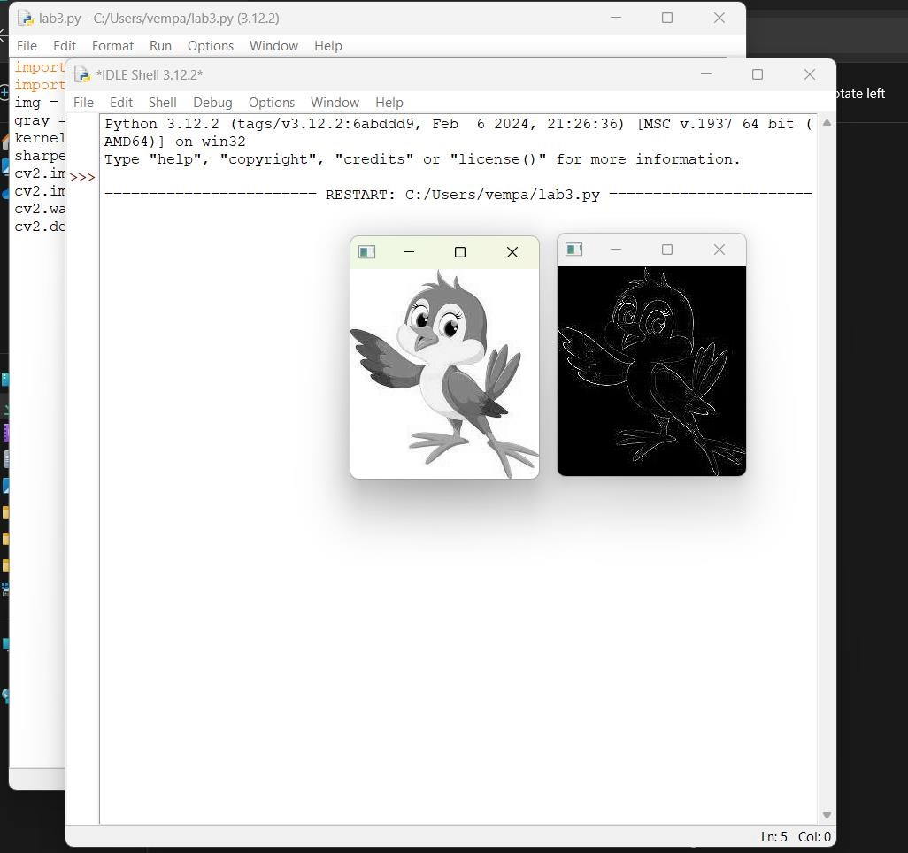

1. **Perform Sharpening of Image using Laplacian mask with positive center coefficient.**

**PROGRAM:**

import cv2 import numpy as np img = cv2.imread(r"C:\Users\vempa\Downloads\BIRD2.jpg") img = cv2.resize(img,(255, 255)) gray_img = cv2.cvtColor(img, cv2.COLOR_BGR2GRAY)

# Apply the Laplacian filter with a positive center coefficient laplacian_kernel = np.array([[0, -1, 0], [-1, 5, -1], [0, -1, 0]]) sharpened_img = cv2.filter2D(gray_img, -1, laplacian_kernel) sharpened_img = cv2.cvtColor(sharpened_img, cv2.COLOR_GRAY2BGR) cv2.imshow('Original Image', img) cv2.imshow('Sharpened Image', sharpened_img) cv2.waitKey(0) cv2.destroyAllWindows() **OUTPUT:**

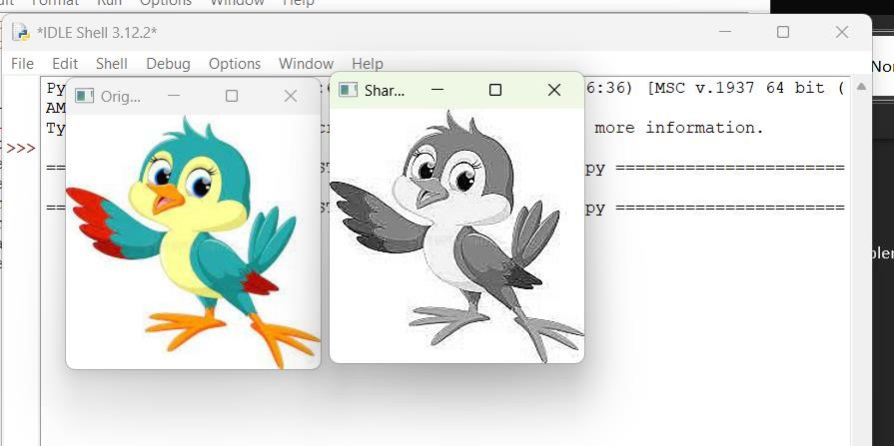

1. **Perform Sharpening of Image using unsharp masking.**

**PROGRAM:**

import cv2 import numpy as np img = cv2.imread(r"C:\Users\vempa\Downloads\BIRD2.jpg") gray = cv2.cvtColor(img, cv2.COLOR_BGR2GRAY) laplacian_kernel = np.array([[0, 1, 0],

[1, -4, 1], [0, 1, 0]]) laplacian = cv2.filter2D(gray, -1, laplacian_kernel) sharpened = cv2.add(gray, laplacian) cv2.imshow('Original Image', gray) cv2.imshow('Sharpened Image', sharpened) cv2.waitKey(0) cv2.destroyAllWindows() **OUTPUT:**

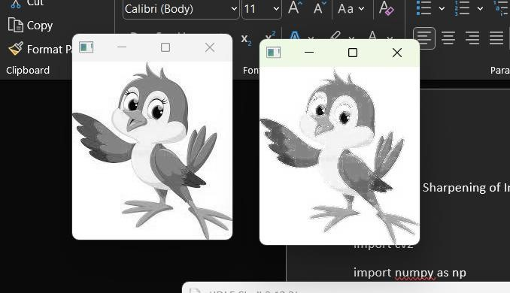

1. **Perform Sharpening of Image using High-Boost Masks.**

**PROGRAM**:

import cv2 import numpy as np # Load the image image = cv2.imread(r"C:\Users\vempa\Downloads\BIRD2.jpg")

# Convert to grayscale gray = cv2.cvtColor(image, cv2.COLOR_BGR2GRAY)

# Apply Gaussian blur blurred = cv2.GaussianBlur(gray, (5, 5), 0) high_boost_mask = gray - blurred

A = 2 # You can experiment with different values of A high_boost_mask = A * high_boost_mask # Add the High-Boost Mask to the Original Image sharpened_image = cv2.add(gray, high_boost_mask) sharpened_image = np.clip(sharpened_image, 0, 255) cv2.imshow('Original Image', gray) cv2.imshow('Sharpened Image', sharpened_image) cv2.waitKey(0) cv2.destroyAllWindows() **OUTPUT** :

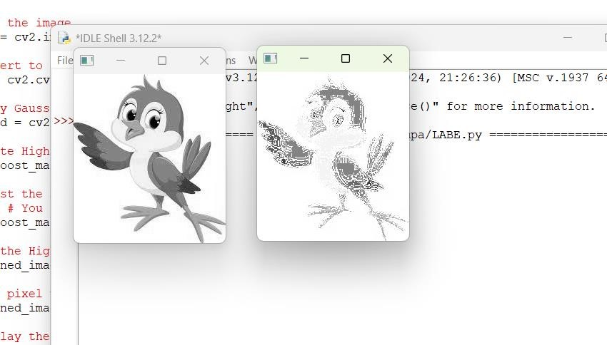

**25. Perform Sharpening of Image using Gradient masking**

**PROGRAM**:

import cv2 import numpy as np def image_sharpening_gradient(image_path, alpha=1.5):

# Load the image original_image = cv2.imread(image_path, cv2.IMREAD_GRAYSCALE)

# Calculate the gradient using Sobel operators gradient_x = cv2.Sobel(original_image, cv2.CV_64F, 1, 0, ksize=3) gradient_y = cv2.Sobel(original_image, cv2.CV_64F, 0, 1, ksize=3) gradient_magnitude = np.sqrt(gradient_x**2 + gradient_y**2) gradient_magnitude = cv2.normalize(gradient_magnitude, None, 0, 255, cv2.NORM_MINMAX) sharpening_mask = original_image + alpha * gradient_magnitude sharpening_mask = np.clip(sharpening_mask, 0, 255) sharpening_mask = np.uint8(sharpening_mask) cv2.imshow('Original Image', original_image) cv2.imshow('Sharpening Mask', sharpening_mask) cv2.waitKey(0) cv2.destroyAllWindows() image_sharpening_gradient(r"C:\Users\vempa\Downloads\BIRD2.jpg", alpha=1.5) **OUTPUT** :

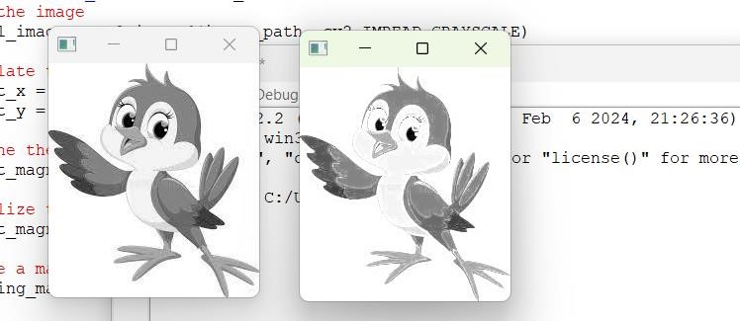

**26. Insert water marking to the image using OpenCV.**

**PROGRAM:**

import cv2 import numpy as np def add_watermark(input_image_path, output_image_path, watermark_path, position=(0, 0), alpha=0.7):

# Load the original image original_image = cv2.imread(input_image_path) # Load the watermark image with an alpha channel watermark = cv2.imread(watermark_path, cv2.IMREAD_UNCHANGED)

# Extract the alpha channel from the watermark alpha_channel = watermark[:, :, 3] / 255.0 # Resize the watermark to fit the desired position h, w = original_image.shape[:2] watermark_resized = cv2.resize(watermark, (w // 5, h // 5)) # Define the region of interest (ROI) for the watermark placement roi = original_image[-watermark_resized.shape[0]:, -watermark_resized.shape[1]:] blended = cv2.addWeighted(roi, 1 - alpha, watermark_resized[:, :, :3], alpha, 0)

# Update the original image with the blended ROI original_image[-watermark_resized.shape[0]:, -watermark_resized.shape[1]:] = blended cv2.imwrite(output_image_path, original_image) cv2.imshow('Watermarked Image', original_image) cv2.waitKey(0) cv2.destroyAllWindows()

add_watermark(r"C:\Users\vempa\Downloads\BIRD2.jpg", r"C:\Users\vempa\Downloads\download (1).png", "C:\drive\OneDrive\Pictures\Screenshots\Screenshot (275).png", position=(0, 0), alpha=0.7) **OUTPUT**:

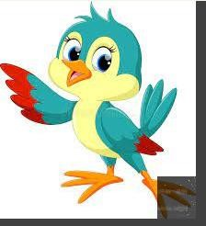

1. **Do Cropping, Copying and pasting image inside another image using OpenCV**

**PROGRAM:**

import cv2 import numpy as np image = cv2.imread(r"C:\Users\vempa\Downloads\BIRD2.jpg") img2 = cv2.imread(r"C:\Users\vempa\Downloads\download (1).png") print(image.shape) # Print image shape cv2.imshow("original", image) imageCopy = image.copy() cv2.circle(imageCopy, (100, 100), 30, (255, 0, 0), -1) cv2.imshow('image', image) cv2.imshow('image copy', imageCopy) cropped_image = image[80:280, 150:330] cv2.imshow("cropped", cropped_image) cv2.imwrite("Cropped Image.jpg", cropped_image) dst = cv2.addWeighted(image, 0.5, img2, 0.7, 0) img_arr = np.hstack((image, img2)) cv2.imshow('Input Images',img_arr) cv2.imshow('Blended Image',dst) cv2.waitKey(0) cv2.destroyAllWindows() **OUTPUT:**

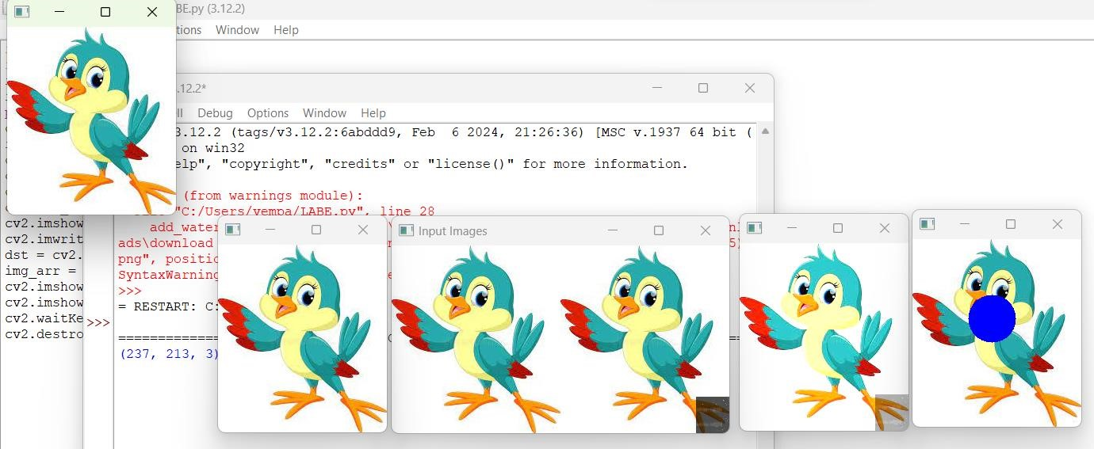

1. **Find the boundary of the image using Convolution kernel for the given image**

**PROGRAM:**

import cv2 import numpy as np img = cv2.imread(r"C:\Users\vempa\Downloads\BIRD2.jpg", cv2.IMREAD_GRAYSCALE) dx = cv2.Sobel(img, cv2.CV_64F, 1, 0) dy = cv2.Sobel(img, cv2.CV_64F, 0, 1) edges = cv2.magnitude(dx, dy) thresh = 100 edges[edges < thresh] = 0 edges[edges >= thresh] = 255 cv2.imshow("Edges", edges) cv2.waitKey(0) cv2.destroyAllWindows() **OUTPUT:**

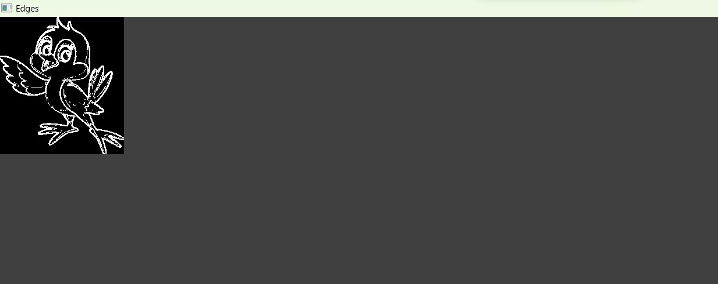

1. **Morphological operations based on OpenCV using Erosion technique**

**PROGRAM:**

import cv2 import numpy as np img = cv2.imread(r"C:\Users\vempa\Downloads\BIRD2.jpg", cv2.IMREAD_GRAYSCALE)

kernel = np.ones((5,5), np.uint8) erosion = cv2.erode(img, kernel, iterations=1) cv2.imshow("Original", img) cv2.imshow("Erosion", erosion) cv2.waitKey(0) cv2.destroyAllWindows() **OUTPUT:**

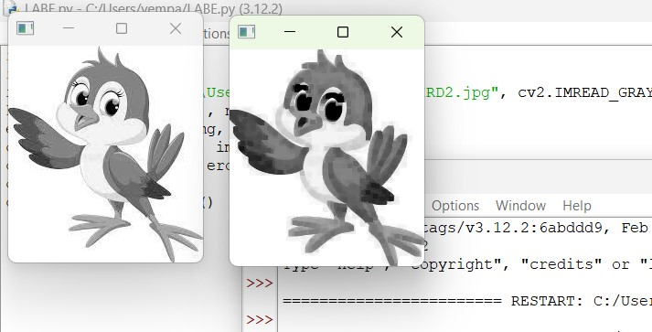

1. **Morphological operations based on OpenCV using Dilation technique**

**PROGRAM**:

import cv2 import numpy as np img = cv2.imread(r"C:\Users\vempa\Downloads\BIRD2.jpg", cv2.IMREAD_GRAYSCALE) kernel = np.ones((5,5), np.uint8) dilation = cv2.dilate(img, kernel, iterations=1) cv2.imshow("Original", img) cv2.imshow("Dilation", dilation) cv2.waitKey(0) cv2.destroyAllWindows() **OUTPUT:**

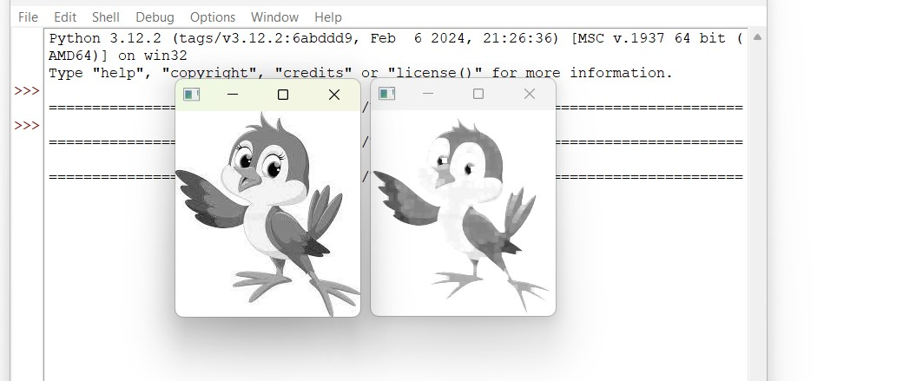

1. **Morphological operations based on OpenCV using Opening technique.**

**PROGRAM:**

import cv2 import numpy as np img = cv2.imread (r"C:\Users\vempa\Downloads\BIRD2.jpg", cv2.IMREAD_GRAYSCALE)

kernel = np.ones((5,5), np.uint8) opening = cv2.morphologyEx(img, cv2.MORPH_OPEN, kernel) cv2.imshow("Original", img) cv2.imshow("opening", opening) cv2.waitKey(0)

cv2.destroyAllWindows() **OUTPUT:**

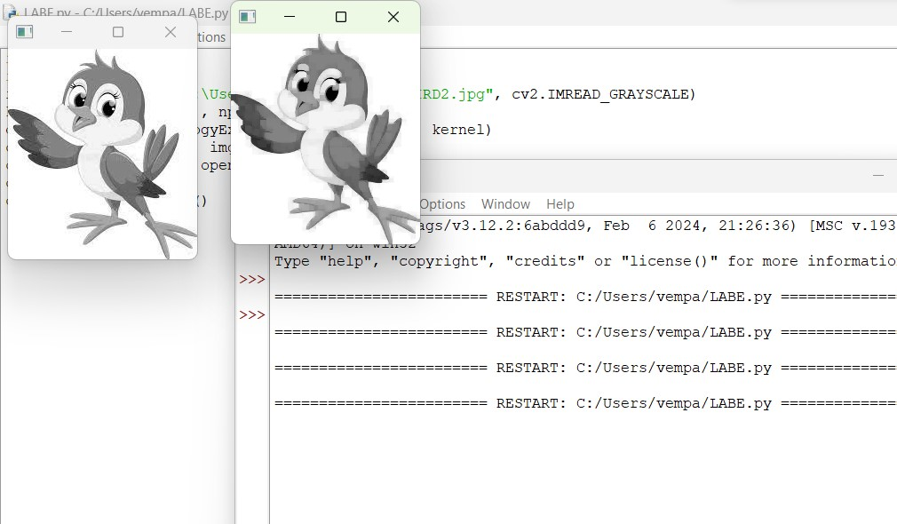

**32. Morphological operations based on OpenCV using Closing technique.**

**PROGRAM:**

import cv2 import numpy as np img = cv2.imread(r"C:\Users\vempa\Downloads\BIRD2.jpg", cv2.IMREAD_GRAYSCALE)

kernel = np.ones((5,5), np.uint8) closing = cv2.morphologyEx(img, cv2.MORPH_CLOSE, kernel) cv2.imshow("Original", img) cv2.imshow("Closing", closing) cv2.waitKey(0)

cv2.destroyAllWindows() **OUTPUT**:

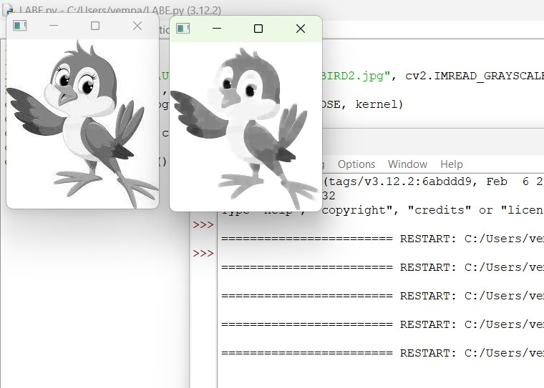

1. **Morphological operations based on OpenCV using Morphological Gradient technique**

**PROGRAM:**

import cv2 import numpy as np img = cv2.imread(r"C:\Users\vempa\Downloads\BIRD2.jpg", cv2.IMREAD_GRAYSCALE) kernel = np.ones((5,5), np.uint8)

grad = cv2.morphologyEx(img, cv2.MORPH_GRADIENT, kernel) cv2.imshow("Original", img) cv2.imshow("Gradient", grad) cv2.waitKey

**OUTPUT**:

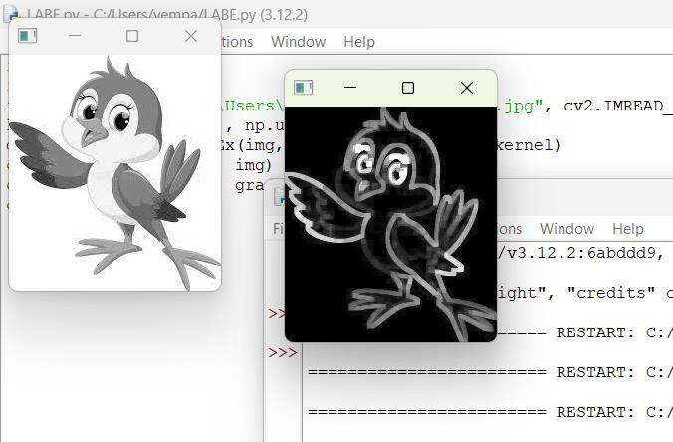

1. **Morphological operations based on OpenCV using Top hat technique.**

**PROGRAM**:

import cv2 import numpy as np img = cv2.imread(r"C:\Users\vempa\Downloads\BIRD2.jpg", cv2.IMREAD_GRAYSCALE)

kernel = np.ones((5,5), np.uint8) tophat = cv2.morphologyEx(img, cv2.MORPH_TOPHAT, kernel) cv2.imshow("Original", img) cv2.imshow("Top Hat", tophat) cv2.waitKey(0) cv2.destroyAllWindows()

**OUTPUT**:

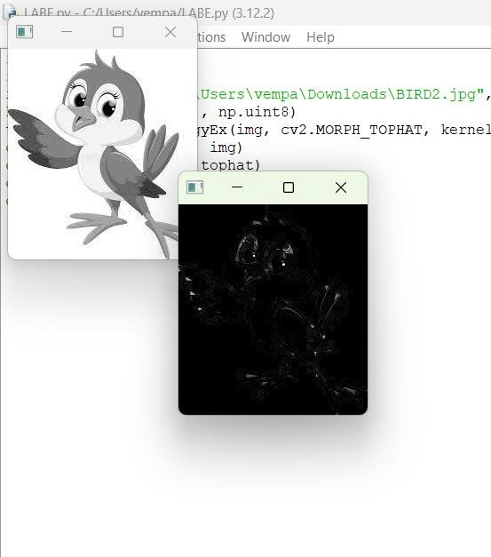

**35. Morphological operations based on OpenCV using Black hat technique.**

**PROGRAM:**

import cv2 import numpy as np img = cv2.imread(r"C:\Users\vempa\Downloads\BIRD2.jpg", cv2.IMREAD_GRAYSCALE)

kernel = np.ones((5,5), np.uint8) blackhat = cv2.morphologyEx(img, cv2.MORPH_BLACKHAT, kernel) cv2.imshow("Original", img) cv2.imshow("Black Hat", blackhat) cv2.waitKey(0) cv2.destroyAllWindows()

**OUTPUT:**

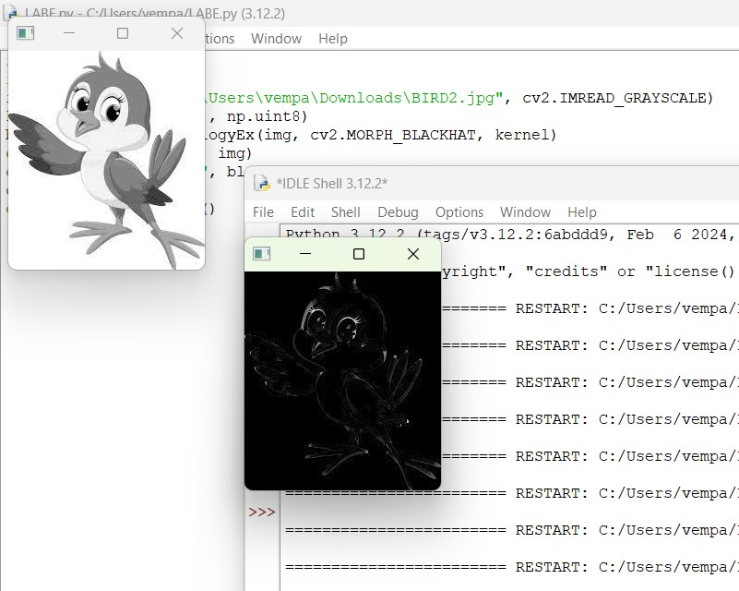

**36. Recognise watch from the given image by general Object recognition using OpenCV.**

**PROGRAM:**

import cv2 watch_cascade = cv2.CascadeClassifier("C:\drive\OneDrive\Documents\watch-cascade.xml") img = cv2.imread("C:\drive\OneDrive\Pictures\Screenshots\Screenshot 2024-02-26 092427.png") gray = cv2.cvtColor(img, cv2.COLOR_BGR2GRAY) watches = watch_cascade.detectMultiScale(gray, scaleFactor=1.2, minNeighbors=5)

for (x, y, w, h) in watches:

cv2.rectangle(img, (x, y), (x + w, y + h), (0, 255, 0), 2) cv2.imshow('Watches Detected', img) cv2.waitKey(0) cv2.destroyAllWindows() **OUTPUT:**

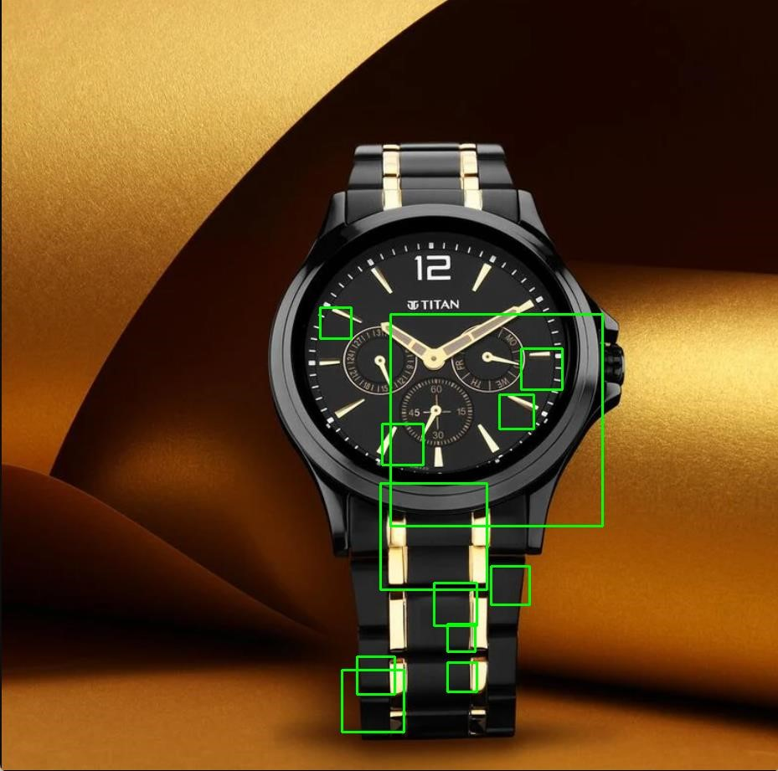

**37. Using Opencv play Video in Reverse mode.**

**PROGRAM:**

import cv2 cap = cv2.VideoCapture(r"C:\Users\vempa\Videos\test.mp4") total_frames = cap.get(cv2.CAP_PROP_FRAME_COUNT)

current_frame = total_frames - 1 while current_frame >= 0: cap.set(cv2.CAP_PROP_POS_FRAMES, current_frame)

ret, frame = cap.read() if not ret: break

cv2.imshow('Video in Reverse', frame) if cv2.waitKey(30) & 0xFF == ord('q'):

break current_frame -= 1 cap.release() cv2.destroyAllWindows() **OUTPUT:**

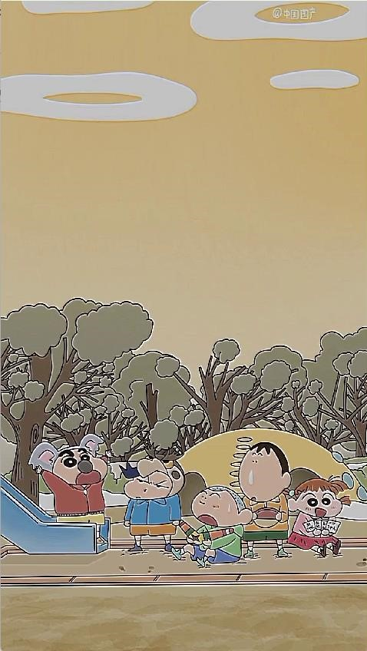

**38. Face Detection using Opencv**

**PROGRAM:**

import cv2 img = cv2.imread("C:\drive\OneDrive\Pictures\Screenshots\Screenshot 2024-02-21 123000.png") gray = cv2.cvtColor(img, cv2.COLOR_BGR2GRAY) face_cascade = cv2.CascadeClassifier("C:\drive\OneDrive\Documents\watch-cascade.xml") faces = face_cascade.detectMultiScale(gray, scaleFactor=1.1, minNeighbors=5)

for (x, y, w, h) in faces:

cv2.rectangle(img, (x, y), (x + w, y + h), (0, 255, 0), 2) cv2.imshow('Faces Detected', img) cv2.waitKey(0) cv2.destroyAllWindows() **OUTPUT:**

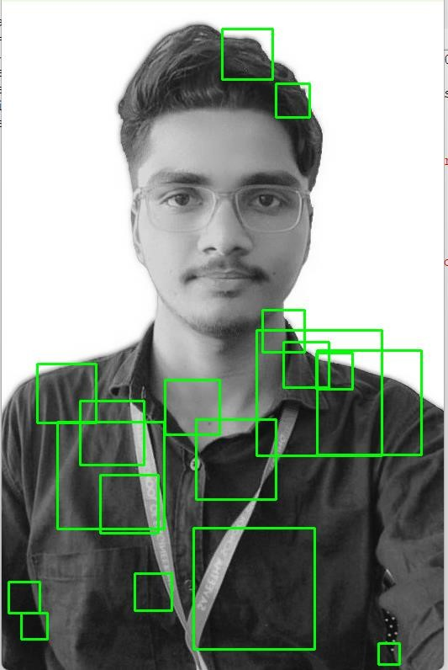

**39. Vehicle Detection in a Video frame using OpenCV**

**PROGRAM:**

import cv2 car_cascade = cv2.CascadeClassifier("C:\\drive\\OneDrive\\Documents\\watch-cascade.xml")

cap = cv2.VideoCapture("C:\\drive\\OneDrive\\Pictures\\Slide Shows\\Ram's\\WA-VID-20200720-

9aa8edb7.mp4") while True:

ret, frame = cap.read() if not ret: break

gray = cv2.cvtColor(frame, cv2.COLOR_BGR2GRAY) cars = car_cascade.detectMultiScale(gray, 1.1, 1)

for (x, y, w, h) in cars:

cv2.rectangle(frame, (x, y), (x+w, y+h), (0, 0, 255), 2) cv2.imshow('frame', frame) if cv2.waitKey(1) & 0xFF == ord('q'):

break cap.release() cv2.destroyAllWindows() **OUTPUT:**

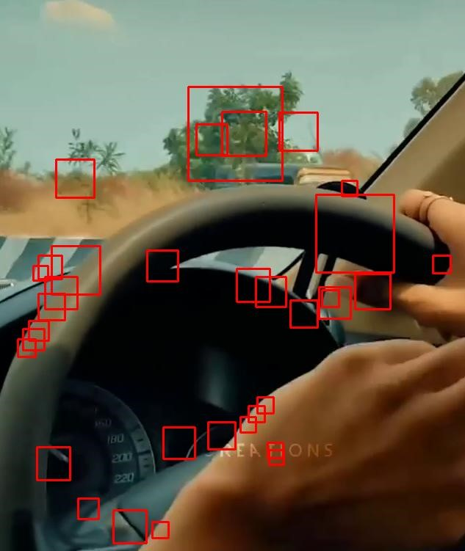

**40. Draw Rectangular shape and extract objects**

**PROGRAM:**

import cv2 img = cv2.imread(r"C:\Users\vempa\Downloads\BIRD2.jpg")

x, y = 100, 100 width, height = 200, 150 roi = img[y:y+height, x:x+width] cv2.imshow('ROI', roi) cv2.waitKey(0) cv2.destroyAllWindows()

**OUTPUT:**

